Part 1: Insert HTML template in sitefinity

Here we are trying to make a complete project of sitefinity using a html template grill. We make the project in part.

* We install sitefinity project using sitefinity tool.
* We run the project on browser using sitefinity tool after that we run it by visual studio (Here we are using visual studio 2015).

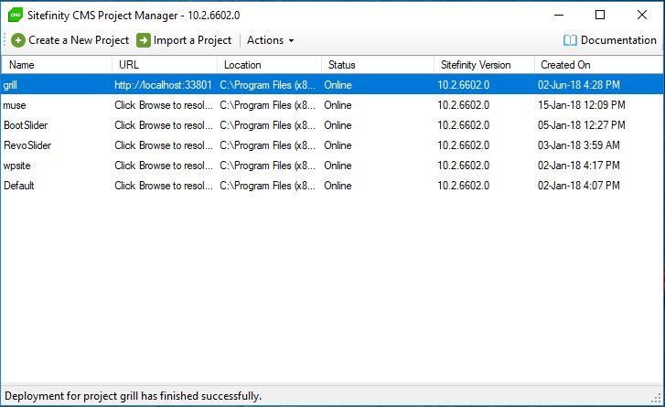

* Now we try to open it on visual studio.

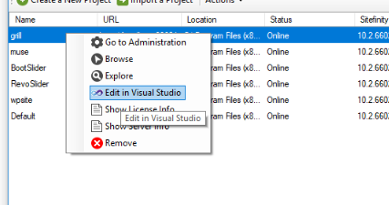

* After open the project grill we try to run the file using visual studio to run it fast we rebuild the project and run it without debugging. If you are using visual studio 2012 you need to change some setting before debugging.
* Solution Explorer > sitefinity WebApp >right click > property web app > click on create virtual directory button.

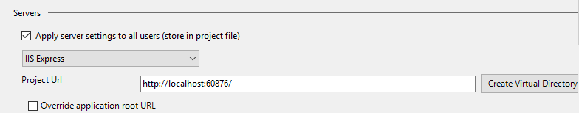

* When it run the file successfully then we create the file structure you need to install sitfinity thunder tool by default it installs when we install sitefinity.
* To create the structure, Go to App_Data right click on it Go to add > new item/ class > Right side panel Sitefinity >Sitefinity website template > select

Rename . (here we are using name it grill you can write the name as your requirement.)

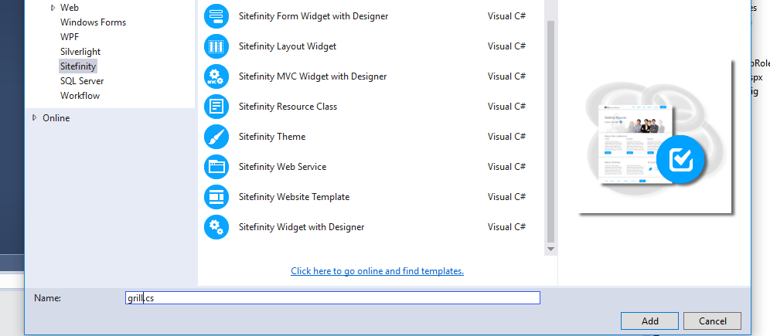

* In App_Data > Sitefinity you find something shows pic

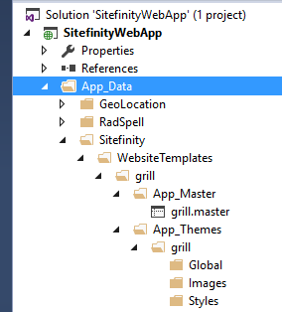

* In App_Master we put our html contents.

.master is the file extension where we write our html.

(In part 2 we give you details of file we use in sitefinity ).

* We put all the html file in the grill.master and css in global

You take the reference from the file which we upload there.

* After inserting the html rebuilt the project and debug it without debugging.
* Logging to backed on sitefinity using browser <http://localhost:60876/Sitefinity/>
* Go to design > Page Templates > create a template > Name > Developer name > use template select another template > use you own .master file >

Browse another folder > App_data > sitefinity > Website Templates > grill > App_Master > Grill.master > select > create and go to add content.

* To load the css click on theme > select the theme > change theme name to grill.
* Click on published you template is ready but to see in browser you need to assignee it to page.
* Go to pages > create a page > name the page (we are creating home so we name it home) template > select the another template > select the template which you made it is on the top > done > create and go to and contents.
* Publish